Top 10 Most Expensive Coffee In The World: 2022 Overview
Url Slug: /most-expensive-coffee-in-the-world

Coffee is a popular, energy-boosting beverage that is consumed all over the world. Coffee chain success stories like Starbucks speak for themselves.

But have you ever wondered what the world's most expensive coffee is?

We list the top ten most expensive coffees in the world, as well as the reasons why they are so expensive.

10. Hawaiian Kona
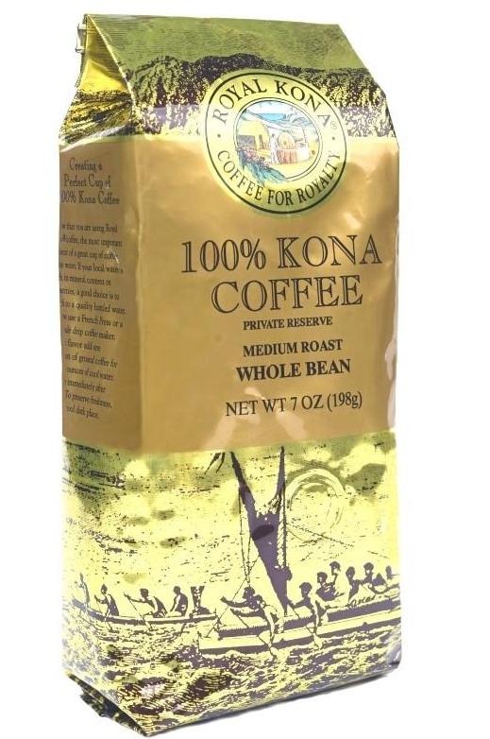
[Image]

The first of ten of the most expensive coffees on our list is Hawaiian Kona. It's one of the world's most expensive coffees.

The coffee labeled "Kona Coffee" has come directly from the Kona district of Hawaii.

Price and Location

It costs $35 per pound. Kona coffee is made from coffee (Coffea arabica) grown on the slopes of Hualalai and Mauna Loa on Hawaii's Big Island's North and South Kona Districts. Kona coffee is only produced in the Kona district.

Sunlight in the mornings, rainy or cloudy afternoons, low wind, and mild evenings, along with porous, mineral-rich volcanic soil, are optimal growing conditions for coffee.

9. Los Planes
[Image]

This delicious coffee is grown in the shade of native trees and has flavors of milk chocolate, caramel, and cherry. This award-winning coffee is available in a variety of flavors, including tangerine with caramel and brown sugar threads, which is rather unusual.

Price and location

This coffee is grown by a small co-operative in Los Planes, Guatemala, by growers who are committed to long-term sustainability as well as Fair Trade and Organic certifications.

It is quite expensive, at $40 per pound, but Los Planes has managed to build up a sizable loyal customer base who enjoy the variety of flavors and the refreshing taste.

8. Fazenda Santa Ines
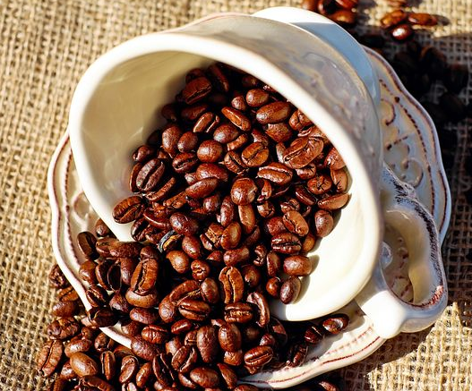

It has been produced for over a century along the base of the Mantiquera mountains in Brazil. This valuable coffee is consumed by a large number of people all over the world. They are drawn to this delectable beverage because it contains a variety of delectable fruits.

It finished eighth in the 2009 Cup of Excellence competition, and critics say it's a great cup for the money.

Price and location

Following that is Fazenda Santa Ines, a Brazilian coffee bean that costs around $50 per pound.

This is well recognized for its fruity and sweet flavor and is grown near the base of the Mantiquera mountains in Brazil.

7. Jamaican Blue Mountain

This coffee is harvested in the Jamaican Blue Mountains at a height of about 5,000 feet. Water is plentiful in this area because it receives a lot of rain. Coffee beans are selected, processed, and distributed to various places.

This drink has a unique, mild flavor with no bitterness. It is widely known in Japan, which is a major importer of the brand.

Price and location

Jamaican Blue, which costs $50 per pound, is grown at an elevation of 5,000 feet in the Jamaican Blue Mountains.

The area where the coffee beans grow receives a lot of rain all year and has fertile soil, which allows the beans to thrive.

6. Moloka’i
[Image]
Molokai coffee, like Kona coffee, is a brand name for a particular origin and quality product. Molokai coffee specifications govern not only the origin and quality of the coffee, but also the design and placement of the label on the product box.

Price and location

Molokai sells for about $51 per pound. It is grown, produced, and roasted in Kualapu'u, Maui County, which has some of the best coffee growing conditions in the world, which is combined with years of skill and refinement.

5. St. Helena
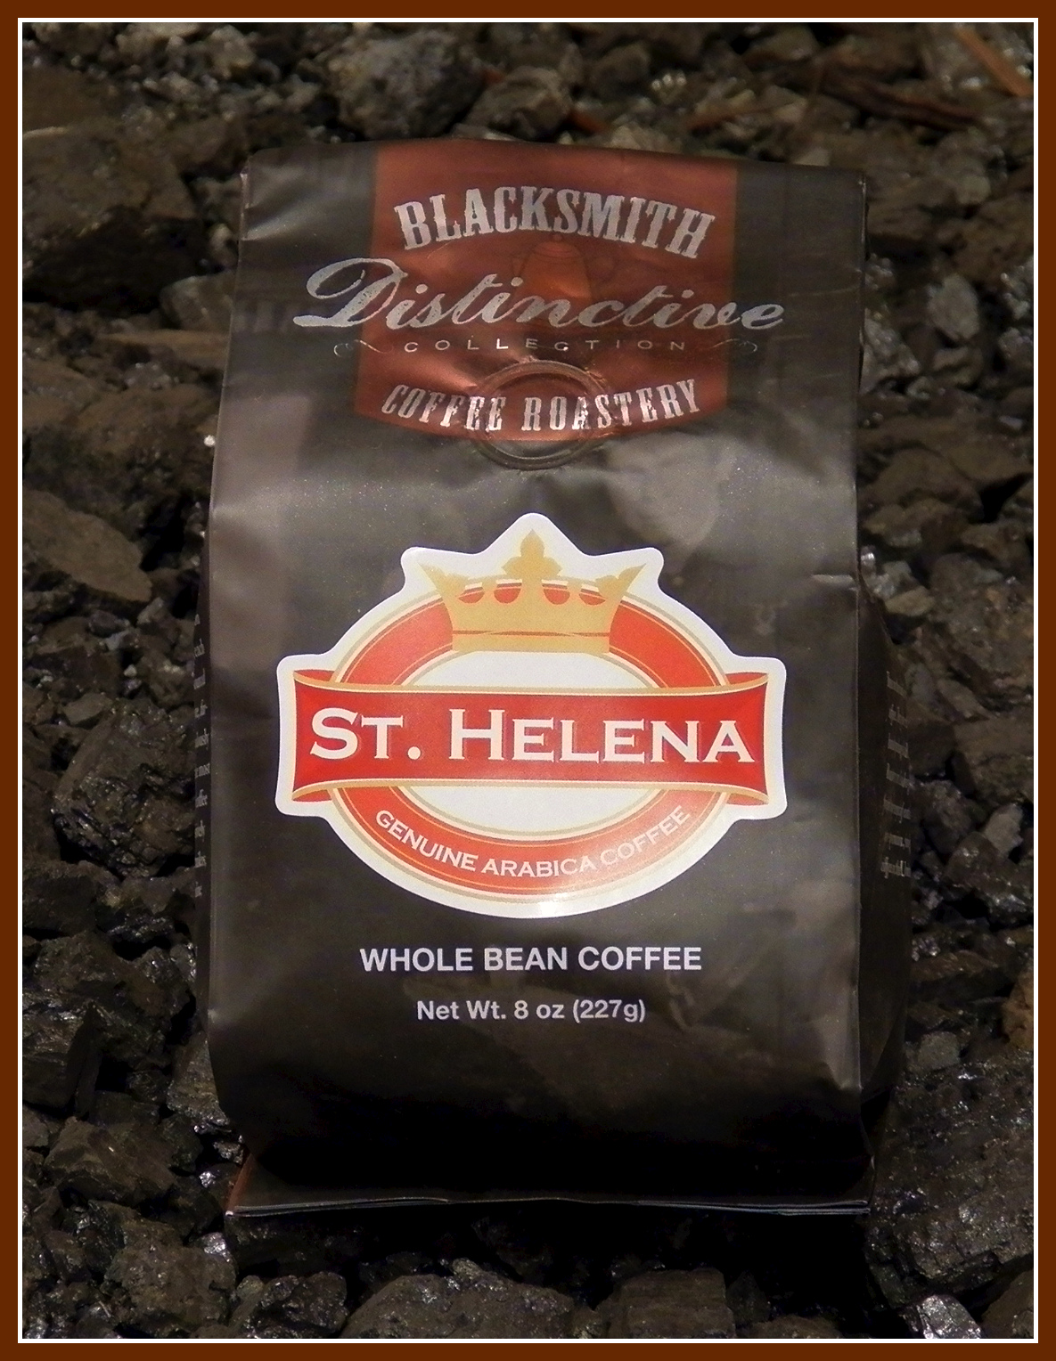
[Image]

St. Helena is a small island in the middle of the Atlantic Ocean, approximately 1,200 miles west of Africa. Its geographical location has a significant impact on the coffee's growing conditions, which are different from other countries.

Price and location

St. Helena is located in the middle of the Atlantic Ocean, approximately 1,200 miles from the west coast of Africa. Its main claim to fame is the imprisonment of Napoleon Bonaparte on the island.

Its geographical location has a significant impact on the conditions under which the coffee is grown, which are unique to the world. Geographically, it's also a difficult location to export from, which contributes to the $79 price tag.

4. Kopi Luwak
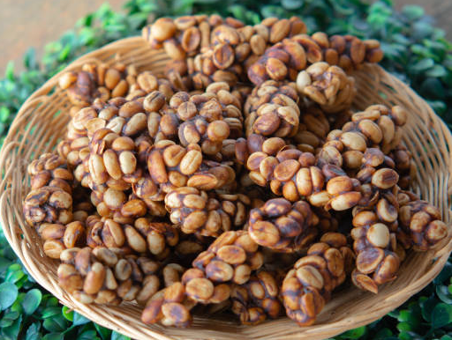

Kopi luwak is a coffee made from partially digested coffee cherries eaten and defecated by the Asian palm civet (Paradoxurus hermaphroditus). Another name for it is civet coffee. The cherries ferment as they pass through a civet's intestines and are then collected after being defecated with other feces.

Price and location

What distinguishes this expensive coffee from the rest is the method by which the producers obtain the coffee beans.

Kopi Luwak coffee is the most well-known coffee on the list, and it costs around $160 per pound.

Kopi luwak is primarily grown on the Indonesian islands of Sumatra, Java, Bali, and Sulawesi, as well as in East Timor.

3. Hacienda La Esmeralda
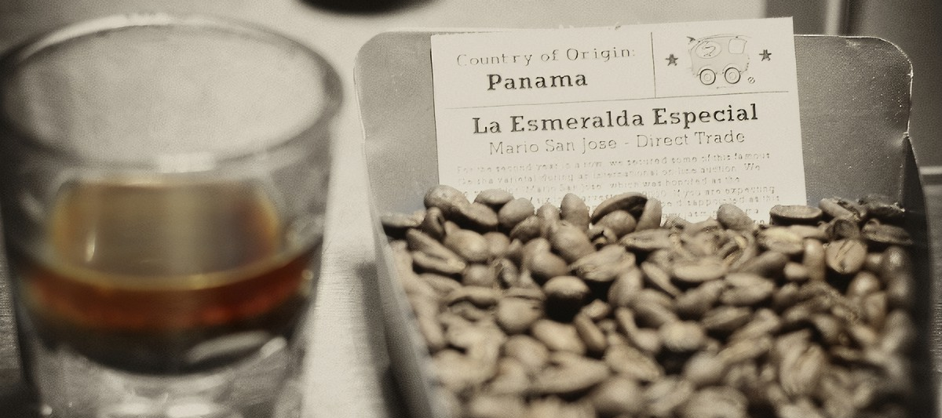
[Image]

Hacienda La Esmeralda ranks third on our list of the most expensive coffees in the world.
This coffee has won numerous first place awards in international coffee competitions over the years.

This rare coffee delicacy provides connoisseurs with a once-in-a-lifetime experience with its wonderful taste and deep flavor.

Price and location

It is grown in the shade of guava trees on the sides of Mount Baru in Panama.

Hacienda La Esmeralda has managed to establish itself as one of the top coffee producers in the world, selling at $350 per pound in a recent auction, acquiring a worldwide customer base, and thus being able to charge appropriately.

2. Finca El Injerto

Finca El Injerto Coffee is expensive because it is made from rare, tiny, and rich beans. The grain quality improves by washing the grains in a single channel and shattering them twice. It is a popular coffee drink loved by coffee enthusiasts all over the world.

Price and location

Finca El Injerto, at a whopping $500+ per pound, is the world's second most expensive coffee.

The majority of the reason this coffee is so expensive is because the small, rich beans from which it is made are extremely rare.

The farm plantations are located in the Huehuetenango Highlands, close to the famous Sierra de los Cuchumatanes, and range in elevation from 1500 masl (meters above sea level) to 1920 masl, where the most delicate and exotic varieties are planted.

1. Black Ivory Coffee
[Image]

This coffee is made in Thailand by the Black Ivory Coffee Company from Arabica beans. Elephants consume Arabica coffee beans and ferment them during digestion, much like civet coffee.

Their stomach acid degrades the bean proteins, resulting in the drink's distinctively strong flavor. This coffee is rare and expensive because only a small amount of beans are available at any given time.

This process ensures that Black Ivory Coffee can produce a smooth, distinct, and delicious cup of coffee.

Price and location

It starts at around $1,000 per pound and can sell for as much as $1,500 per pound.

The Black Ivory Coffee Company is based in Northern Thailand, and like the previously mentioned Kopi Luwak coffee, they have developed a one-of-a-kind coffee producing process that most people would not expect.

Black Ivory Coffee produces coffee on their plantation by feeding Arabica cherries to elephants.

FAQs About The Most Expensive Coffee In The World

Which country has the most expensive coffee?

Black Ivory Coffee is the most expensive coffee in the world. It starts at around $1,000 per pound and can sell for as much as $1,500 per pound.

What does the most expensive coffee taste like?

Pre-barrel black ivory coffee beans have notes of chocolate, tamarind, spice, and a hint of grass. The flavor is very smooth, with no burnt or bitter aftertaste like regular coffee.

